1.
Write a C program to simulate Real-Time CPU Scheduling
algorithms:
Earliest-deadline First
Proportional share scheduling

#include <stdio.h>

#define MAX 10

typedef struct {
int id;
int arrival;
int burst;
int deadline;
int remaining;
int completed;
} Process;

int main() {
int n, i, t = 0, completed = 0;
Process p[MAX];

printf("Enter number of processes: ");
scanf("%d", &n);

float U = 0;

// Input
for (i = 0; i < n; i++) {
printf("Enter arrival time, burst time, deadline for P%d: ", i+1);
scanf("%d %d %d", &p[i].arrival, &p[i].burst, &p[i].deadline);

p[i].id = i + 1;
p[i].remaining = p[i].burst;
p[i].completed = 0;

U += (float)p[i].burst / p[i].deadline;
}

// Feasibility check
if (U > 1) {
printf("\nScheduling not feasible (deadlines may be missed)\n");
return 0;
} else {
printf("\nScheduling feasible\n");
}

int gantt[100];

// EDF Scheduling
while (completed < n) {
int idx = -1;
int min_deadline = 9999;

// Find process with earliest deadline
for (i = 0; i < n; i++) {
if (p[i].arrival <= t && p[i].remaining > 0) {
if (p[i].deadline < min_deadline) {
min_deadline = p[i].deadline;
idx = i;
}
}
}

if (idx == -1) {
gantt[t] = 0; // idle
t++;
continue;
}

// Execute process
gantt[t] = p[idx].id;
p[idx].remaining--;

if (p[idx].remaining == 0) {
p[idx].completed = 1;
completed++;
}

t++;
}

// Print Gantt Chart
printf("\nGantt Chart:\n|");
for (i = 0; i < t; i++) {
if (gantt[i] == 0)
printf(" Idle |");
else
printf(" P%d |", gantt[i]);
}

printf("\n0");
for (i = 1; i <= t; i++) {
printf(" %d", i);
}

printf("\n\nAll processes completed by time %d\n", t);

return 0;
}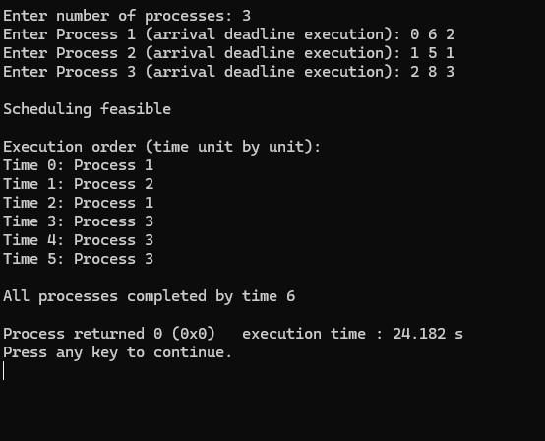
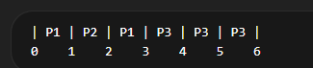

2)
#include <stdio.h>

#define MAX 10

typedef struct {
int id;
int burst;
int remaining;
int weight;
int completed;
} Process;

int main() {
int n, TIME_QUANTUM;
Process p[MAX];

printf("Enter number of processes: ");
scanf("%d", &n);
for (int i = 0; i < n; i++) {
printf("Enter burst time and weight for P%d: ", i + 1);
scanf("%d %d", &p[i].burst, &p[i].weight);

p[i].id = i + 1;
p[i].remaining = p[i].burst;
p[i].completed = 0;
}

printf("Enter TIME_QUANTUM: ");
scanf("%d", &TIME_QUANTUM);

int total_weight = 0;
for (int i = 0; i < n; i++)
total_weight += p[i].weight;

int gantt[200], g = 0;
int completed = 0;
while (completed < n) {
for (int i = 0; i < n; i++) {
if (p[i].completed)
continue;

int slice = (p[i].weight * TIME_QUANTUM) / total_weight;

if (slice <= 0)
slice = 1;

if (slice > p[i].remaining)
slice = p[i].remaining;

for (int k = 0; k < slice; k++) {
gantt[g++] = p[i].id;
}

p[i].remaining -= slice;

if (p[i].remaining <= 0) {
p[i].completed = 1;
completed++;
total_weight -= p[i].weight;
}
}
}

printf("\nGantt Chart:\n|");
for (int i = 0; i < g; i++) {
printf(" P%d |", gantt[i]);
}

printf("\n0");
for (int i = 1; i <= g; i++) {
printf(" %d", i);
}

printf("\n\nAll processes completed at time %d\n", g);

return 0;
}
